**The Stephen James**

**CSRA Coin Club of Aiken**

**P.O. Box 11**

**New Ellenton, SC 29809**

**Web site: www.sjcsracc.org**

**The SJ CSRA CC of Aiken, SC meets on the 1st Thursday of the month at the Aiken Public Library**

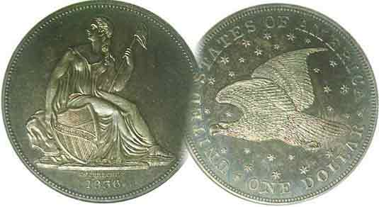

**Pres. J.J. Engel**

**V .P. Pat James**

**Sec. Jim Mullaney**

**Treas. Chuck Goergen**

**Sgt. in Arms: Jim Sproull**

**Programs: Pat James**

**ANA Rep.: Glenn Sanders**

**Show Chair: Board members**

**Photos: Steve Kuhl**

**Publicity: Pat James**

**Newsletter: Arno Safran**

**E-Mail:** [**arnosafran@comcast.net**](mailto:arnosafran@comcast.net)

**Auctioneer: Jim Sproull**

**Web site: Susie Nulty= (see above.)**

**Our next meeting is Thurs. November 7 at the Aiken Public Library, starting time 6:45 PM**

**Volume 18, No. 11 the Stephen James CSRA Coin Club, Founded in 2001 November, 2019**

**Monthly Newsletter**

**SJ CSRA CC Awarded South Carolina Club of the Year!**

**2019 Club Meeting Schedule**

Jan. 3 Apr. 4July 11 Oct. 3

Feb. 5 May 2 Aug. 1 **Nov. 7**

Mar. 7 June 6 Sept. 5 Dec. 5

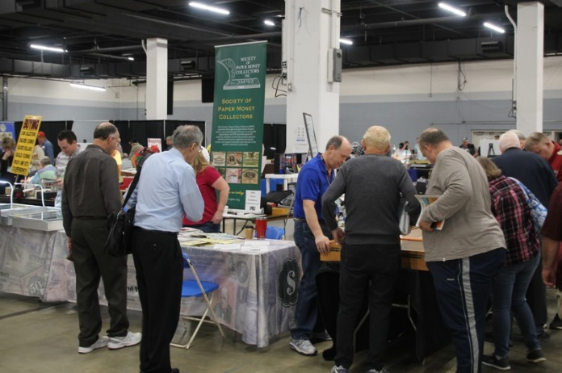

**The 2019 47th SCNA Convention on opening day.**

The Editor recently returned from attending the 47th South Carolina Numismatic Association convention held in the lovely city of Greenville, SC. He was witness to a number of pleasant surprises aside from enjoying the show itself. After a series of location changes due to the increase in dealer and collector attendance the SCNA was able to use the right side of the Convention’s main entrance, which turned out to be the perfect fit. The large room included a central area for exhibits, and at the left center was an excellently run food concession with round tables nearby, as well plus a large meeting room to hold the Sunday breakfast meeting for dealers and SCNA members. At this meeting was our former club president Steve Kuhl, who was just re-elected to his second term as a member of the SCNA Executive Board. Steve is also the Editor of SCNA’s quarterly journal T***he* *Scanner.*** Hewas cited by outgoing SCNA president Randy Clark for the four excellent issues he produced during the SCNA’s 2019 fiscal year. At this ceremony our club was presented with the “SCNA Club of the Year award for second time, the first time was in 2002 following the Club completing its charter year. As far as the numismatic aspects of the show. the bourse had a number of very attractive and tempting numismatic items for purchase and a series of very fine original exhibits. More information on the Convention is contained elsewhere in this newsletter.

**Modern Commemorative Set One Couldn’t Resist** By Arno Safran

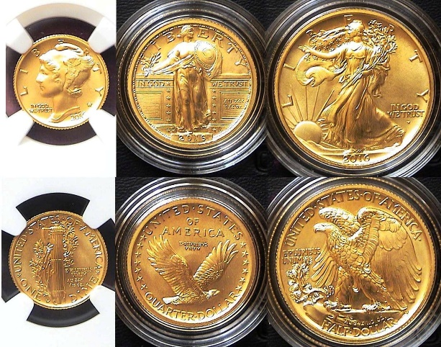

E

**The three 2016 W Gold dimes, quarters and Halves**

**[Use 3 power glass or magnify page to fill monitor screen]**

In 2016, The US Mint decided to celebrate the one hundredth anniversary of the striking of Adolph Weinman’s *Mercury* dime, Hermon McNeil’s Standing liberty quarter and Weinman’s Walking Liberty half-dollar, three of the more popular collectible obsolete coin designs in US history. These denominations were originally struck in .900 fine silver with a reeded edge..

All three 2016 gold centennial versions were struck with reeded edges as well but in .9999 fine gold instead of .9167 which had been the standard for the modern bullion gold eagles series introduced in 1986. To make matters simple, the Mint chose the same diameters for the three 2016 respective denominations as seen on the 1/10oz, $5.00 gold eagle, the 1/4 oz, $10.00 gold eagle and 1/2 ounce, $25.00 gold eagle bullion issues, thus reducing the size of the 2016 gold *Mercury* dime from the silver 17.9 mm to 16.5 mm, the gold Standing Liberty quarter from the silver 24.3 mm to 22.mm, and the gold Waling Liberty gold half from the silver 30.6 mm to 27mm respectively, the other difference being the aforementioned increase in gold content from .9167 fine to .9999.

While these factors were published by the Mint, also appearing in both *Numismatic News* and *Coin World* as well***,*** many collectors who intended to buy the 2016 gold anniversary set were surprised upon receiving the smaller size coinage and the author ashamedly was one of them.

_______________________________________________________________________________________________________-

(Continued on page 2, column 1)

**A Modern Commemorative Set One Couldn’t Resist**

(Continued from page 1, column 2)

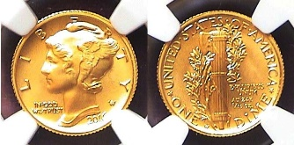

**The 2016-W gold Mercury dime certified by NGC as MS-70**

**[Use 3 power glass or magnify page to fill monitor screen]**

The gold commemorative *Mercury* dime was released on April 21, 1916 at a price of $205. The total mintage was 124,885. Unfortunately, the powers that be either overlooked or were unaware of the importance of the bands located on the fasces of the reverse of the original silver coin when it came to the original silver dime’s numismatic value. For more than a two generations, an uncirculated *Mercury* dime, with fully split bands on the reverse has commanded a premium over those uncirculated examples that lacked that feature. Most numismatic sources accessing the quality of a US coin now include a coin’s strike as a condition of its numismatic worth that involve similar subtly on other more modern coins *such as* ***full head*** Standing Liberty quarters vs. flat head or *full bell lines* on the reverse of the Franklin half-dollar as well as ***full steps*** on Monticello on the reverse of the Jefferson nickel yet when it came time to produce the gold versions celebrating the 100th anniversary of the *Mercury* dine in 2016, the ***full bands*** were overlooked as all of the specimens lacked that important if subtle feature.

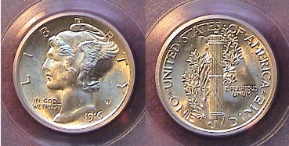

**An actual 1916 *Mercury* dime graded MS-64 Full Bands by PCGS**

**[Use 3 power glass or magnify page to fill monitor screen]**

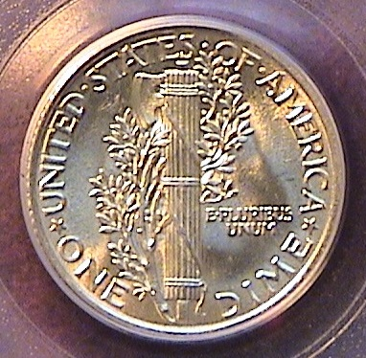

**The reverse of the 1916 *Mercury* dime enlarged sufficiently**

**to show the full bands on the reverse**

Had this full bands been considered, the inaugural release of the first of the three 1916 new gold replicas would have been heralded instead of receiving a ho-hum sigh from most collectors. As a result, the author decided to pass on the dime when introduced, only to reverse his decision three years later when he acquired a Gem certified NGC MS-70 early strike specimen at a local coin shop three years later.

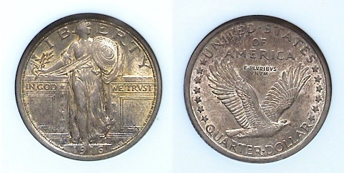

**A 1916 original Standing Liberty quarter graded MS-62 by NGC**

**[Use 3 power glass or magnify page to fill monitor screen]**

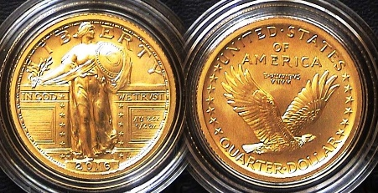

**The 2016-W gold version of the 1916 Standing Liberty quarter**

**Grading either MS-69 or MS-70 shipped directly from the Mint**

**[Use 3 power glass or magnify page to fill monitor screen]**

When it was time to strike the 2016 gold version of the standing Liberty quarter the engraver was able to produce a full head well struck replica of this marvelous coin type originally designed by sculptor Hermon MacNeil. As a result, those interested in acquiring the coin were quite pleased with the result as most specimens also displayed all of the tiny dots surrounding Miss Liberty’s Shield featured on the obverse of the coin. The mintage came to 91,752

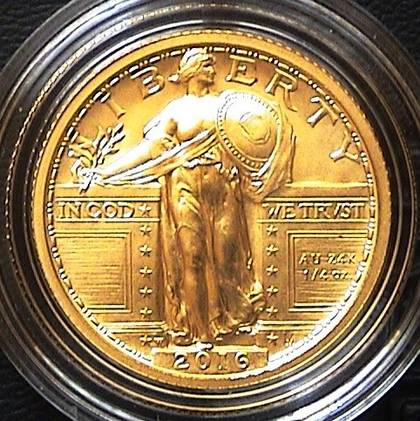

**Enlargement showing the full head and dots surrounding the shield**

**[Use 3 power glass or magnify page to fill monitor screen]**

If one were to buy an original 1916 silver Standing liberty quarter in the same grade as the West Point Mint example shown above, it would cost over $100,000 since a recent example certified MS-65 FH sold for close to $35,000. On the other hand, the asking price for the 2019 gold replica which went on sale between Sept 8 thru Sept. 20, 2016.was only $485. The mintmark **W** for West Point was placed in the same spot on the obverse as the silver versions of the Standing Liberty quarter, directly to the right of the bottom first star at the left of Miss Liberty’s sandal just above the date. It is barely noticeable on the enlargement shown directly above if magnified to 200%.

**_________________________________________________________________________________________________________________**

(Continued on page 3, column 1)

**A Modern Commemorative Set One Couldn’t Resist**

(Continued from the preceding page )

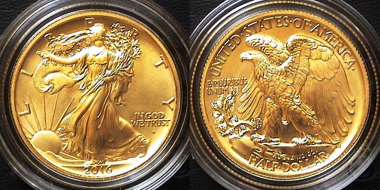

**The 2016-W Gold version of the Walking Liberty half-dollar**

**Grading either MS-69 or MS-70 shipped directly from the Mint**

**[Use 3 power glass or magnify page to fill monitor screen]**

Adolf Weinman’s Walking Liberty obverse and eagle reverse has often been considered a close second to Augustus Saint-Gardens’ double eagle first struck in 1907 as one of the two best coinage designs not only of the United States but in the world, at least since the Philadelphia Mint began striking its own coinage in 1793. This is probably why the obverses of both design-types were chosen to adorn the American gold and silver eagle bullion coinage first released in 1986.

Seeing the Walking Liberty half-dollar struck in .9999 fine gold is also a collector’s dream come true and this virtual MS-70 specimen shown above is akin to an art lover contemplating a masterpiece except for the fact that it is only one of 65,509 pieces struck. The minor errors that plagued the initial production of the gold version of the 1916 *Mercury* dime were corrected as the success of the beautiful rendering of the 2016 gold Standing Liberty quarter demonstrates. The production of the gold version of Weinman’s half-dollar masterpiece of 1916 was also acclaimed by numismatists interested in obtaining a specimen. The initial price for the 24 carat gold commemoratives was based on the price of gold at the time which was hovering closer to $1,250, .so the gold issue of the 2016-W half was priced at $845 at the time the author ordered his specimen.

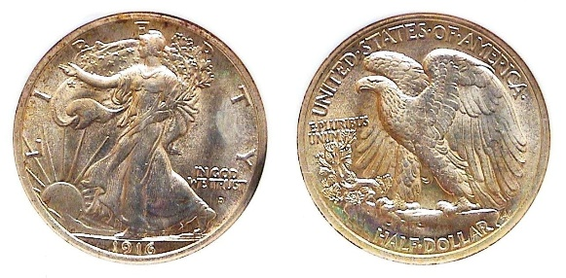

**A 1916-D silver Walking Liberty half-dollar graded MS-64 by NGC**

**[Use 3 power glass or magnify page to fill monitor screen]**

When the original 900 fine silver Walking Liberty half-dollar was first struck in 1916, it was produced at the Philadelphia, Denver and San Francisco Mints. Of the three, the Denver issue with 1.014,00 struck appears to surface more often than the 1916-P with a mintage of just 608,000 while the 1916-S--with a mintage of only 508,000--is considered a rarity in today’s numismatic marketplace. While a large number were saved as a first year issue, many of the 1916 Philadelphia mint issues appear as Choice AU’s as well as MS-63s compared with the 1916-D which is more common in MS-63 and 64. In 1916 and through a part of 1917, the mintmark was placed under the date on the obverse before being transferred to the reverse later in 1917. The 2016 gold replica shows the **W** for West Point mintmark under the date.

With gold currently hovering around $1,500 as this is being written dealers selling the 2016 gold Walking Liberty half-dollar containing ½ oz of gold are advertising specimens housed in NGC-70 first generation holders from $850 to $1,000.

**The 2016 gold Set showing the order reversed**

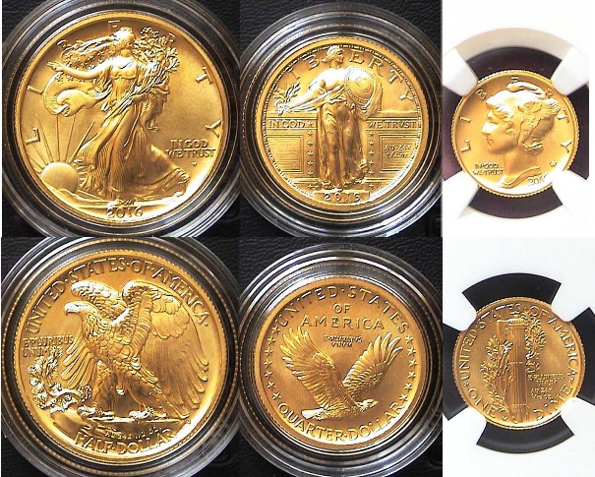

**The 2016 gold WL half, SL 25c and *Mercury* dime**

**[Use 3 power glass or magnify page to fill monitor screen]**

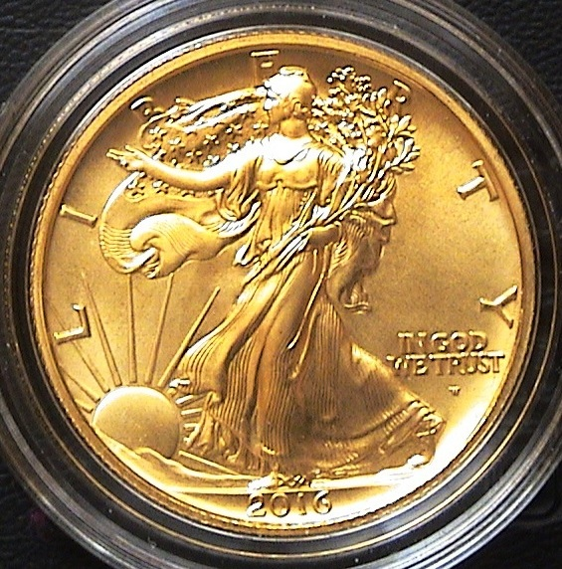

**The obverse 2016 Walking Liberty gold commemorative enlarged**

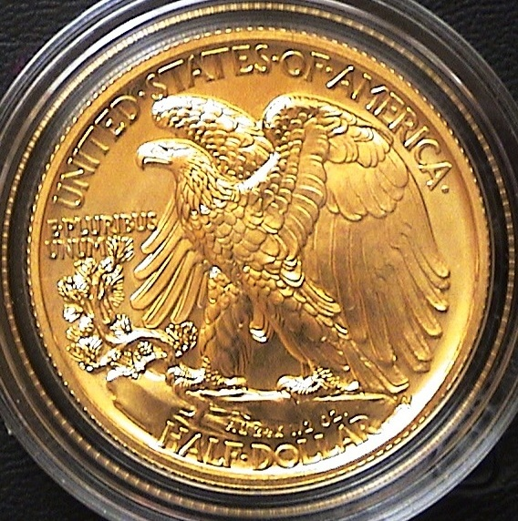

**The reverse 2016 Walking Liberty gold commemorative enlarged**

**______________________________________________________________________________________________________**

***Club and Members win***

***SCNA Awards!***

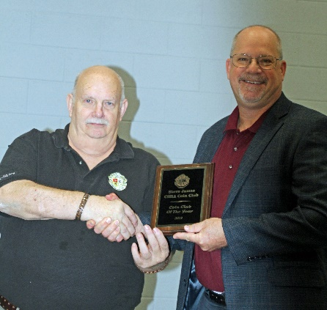Congratulations to the wonderful members of the Stephen James CSRA Coin Club on winning the 2019 Club of the Year Award from the South Carolina Numismatic Association! Announcement of the award was made on October 27th, 2019 at SCNA’s annual Awards Breakfast. This recognition ceremony is hosted by SCNA during their annual Convention. Present to accept the award on behalf of the Club was Past President Steve Kuhl.

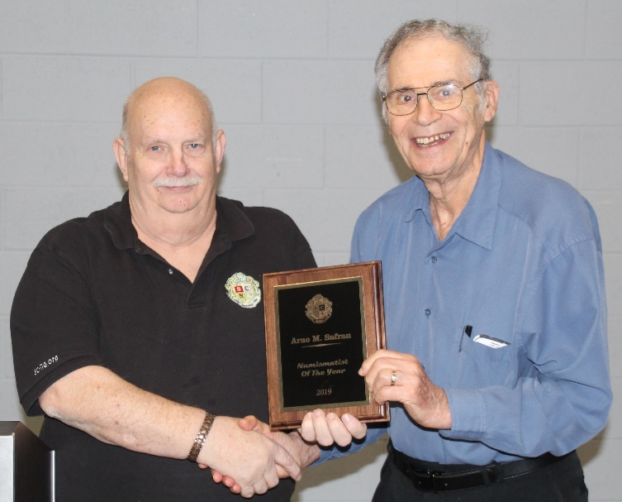In addition to this, Mr. Arno Safran, Club member and Editor of the Club’s newsletter, won SCNA’s Numismatist of the Year award for his efforts in support of both the Aiken and Augusta Clubs! This is the second time Arno has received this distinguished honor, the previous time being eleven years ago in 2008. Congratulations Arno, this recognition is well deserved!

A final award was given to Past President Kuhl when he received SCNA’s Membership Award in recognition of his efforts in sponsoring new members into the organization.

***Fun, Education, Comradery The 2019 SCNA Convention!***

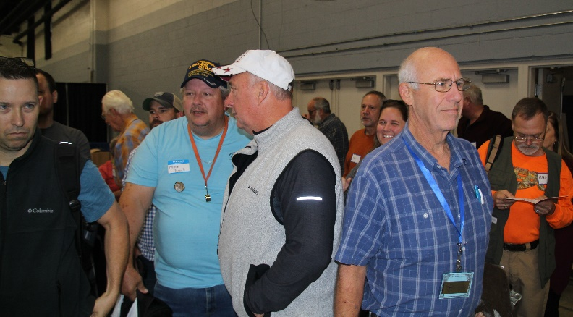The South Carolina Numismatic Association (SCNA) held its annual convention from October 25 through October 27, 2019 at the Greenville Convention Center in Greenville, SC. From the very start the atmosphere was full of excitement as Thursday was filled with dealer to dealer trading and shopping by the early birds and Volunteers who help set up the show!

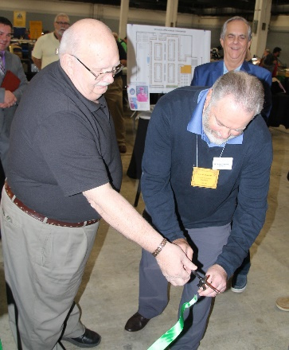With almost 90 dealers manning approximately 200 tables, the momentum continued to build on Friday. It started when the official opening ceremony took place at 10 a.m. An invocation was provided by the Reverend Daniel Westberry, Pastor at the Pentecostal Church of the Upstate in Greenville. This was followed by SCNA President Randy Clark (l) and American Numismatic Association President (and retired U. S. Army Colonel) Steve Ellsworth (r) cut the opening ribbon for the awaiting crowd. Friday’s trading was brisk and there was a very good crowd throughout the day.

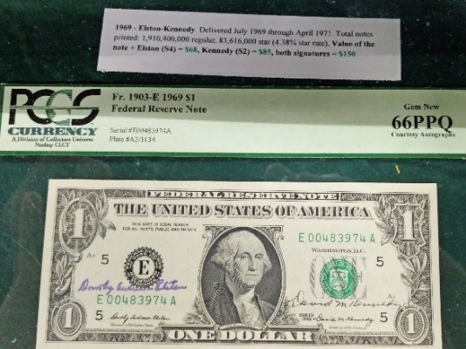Along the center aisle of the bourse floor was a section of tables containing numismatic exhibits entered into competition for trophies and gold and silver coins prizes. The exhibit topics were varied, including Will Gragg’s first place winning exhibit of autographed courtesy notes;

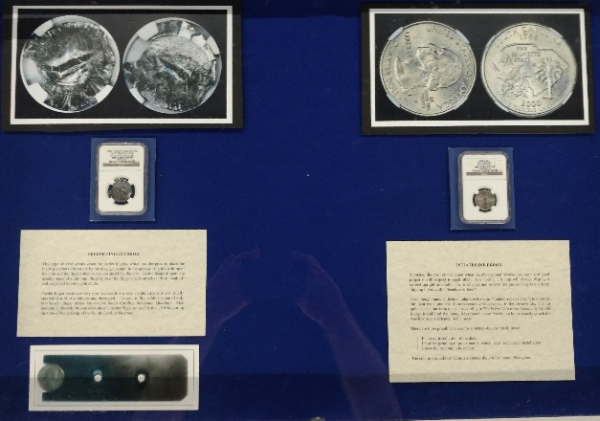 Bob Moon’s second-place winning collection of South Carolina error quarters, and SJCSRACC Member Tony Chibbaro’s fifth-place winning exhibit on S. M. Ward and the Prospect Hill Plantation.

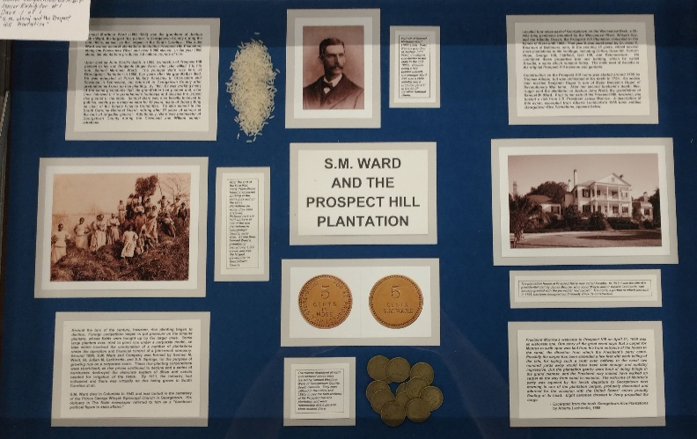

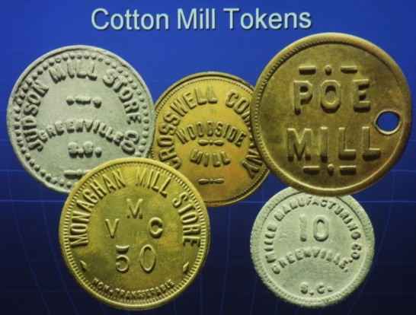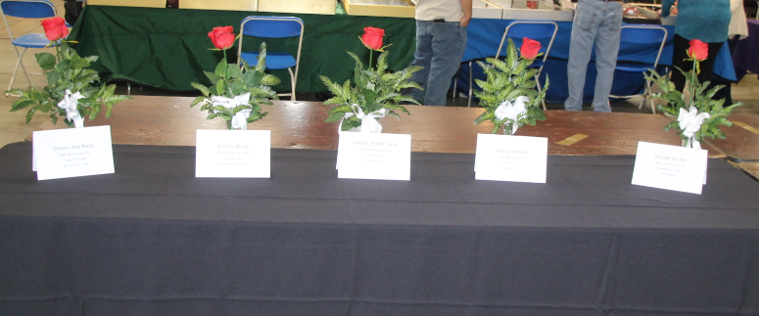On a more somber note, the SCNA lost five Life Members in the past year. Showing respect for the contributions of these individuals a memorial table was set up which held a single memorial rose for each of these five individuals.

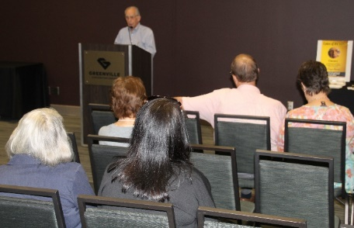Saturday the bourse opened again at 10 a.m. but there was also plenty of action in an adjacent room where three special seminars were held. First was a presentation by Mr. Wayne Damron on *The Coins of the Bible*.

Wayne discussed several key coins mentioned in the Bible, but even better he had examples of each which he graciously passed around the room, allowing the audience to hold and photograph these pieces of history, one of which was 2,500 years old.

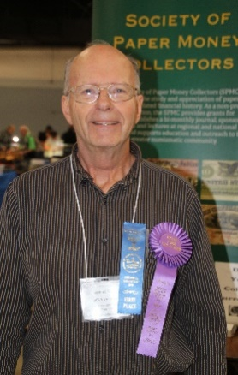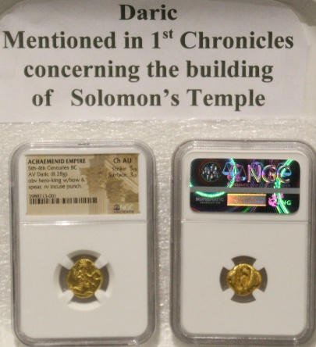His seminar was followed by a presentation from Bob Moon, ANA award winner and well-known currency archivist and evaluator for Heritage Auctions. Bob’s seminar was on *Collecting National Bank Notes*. He provided background on these notes as well as tips for successfully collecting. His talk was followed by an extensive question and answer exchange between he and the audience.

The final seminar of the day was conducted by SJCSRACC member Tony Chibbaro. Tony’s topic was on *Collecting Tokens for Fun and Profit*. His slide show focused on South Carolina tokens and was full of the many categories of tokens available, such as military, lumber mills, cotton mills, bakeries, and saloons. He highlighted several tokens he had recently purchased at the SJCSRACC show held this past September.

These were three excellent presentations and they certainly were well-received by the audiences!

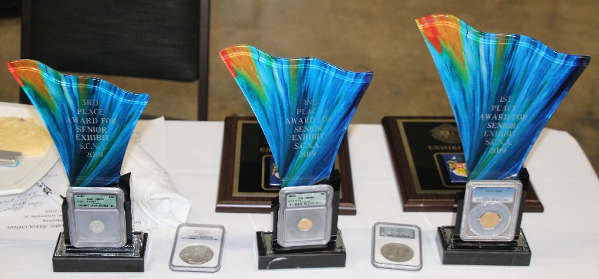

**Exhibit Competition Trophies, Plaques, and Coins!**

Throughout the convention Mr. Will Gragg, SNCA’s Director of Young Numismatists, conducted a YN Carnival. YNs played games, answered quiz questions and won coins, gift certificates that they could redeem on the bourse floor, and they received a free goodie bag of items donated by the ANA and SCNA members!

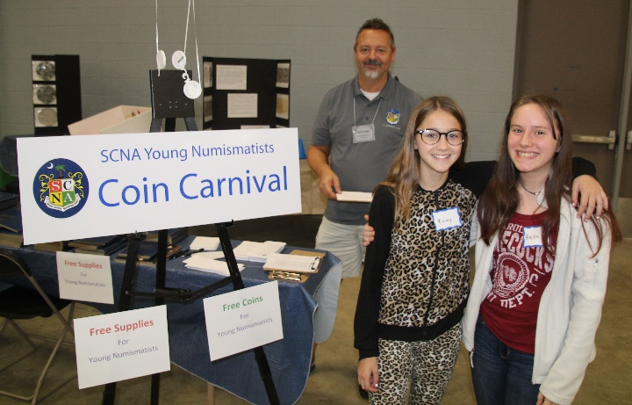

**SCNA YN Director Will Gragg, background, at the YN Carnival with participants Kacey Paige (l) and Alexis White (r)**

As if this wasn’t enough work, Mr. Gragg, supported by Volunteer Walter McGee of the Greenville Coin Club, also conducted a Scouting Merit Badge clinic for 12 Scouts, some from as far away as Fort Bragg, North Carolina!

Sunday was the final day of the Convention and it started with an Awards Breakfast that was open to all SCNA members. This meal was well-attended and featured a wonderful buffet breakfast of eggs, cheese grits, bacon, breads, granola, fruits and yogurts, coffee and juice.

**Scout Volunteer Walter McGee of the Greenville Coin Club guides Scout Bryan Hanson from Troop 776, Ft. Bragg, NC**

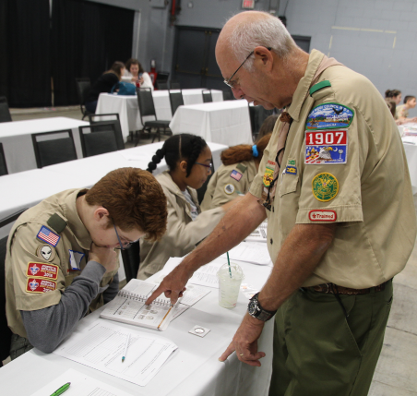

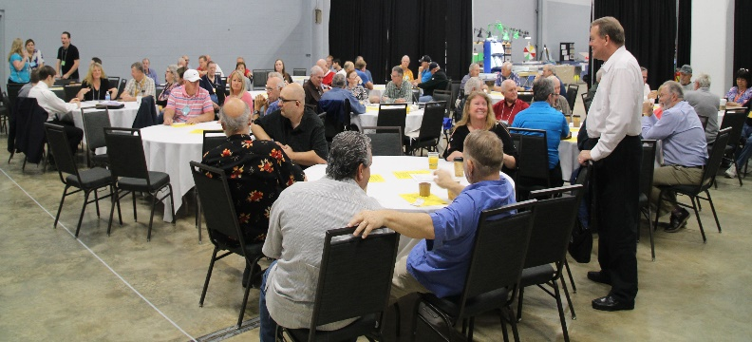

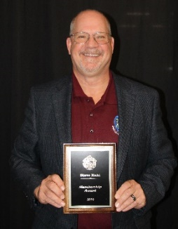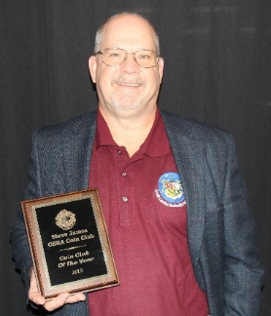The Stephen James CSRA Coin Club of Aiken SC and the Augusta (GA) Coin Club shared Club of the Year honors. SJCSRACC member and newsletter editor Mr. Arno Safran was recognized as SCNA’s Numismatist of the Year and SJCSRACC Past President Steve Kuhl received SCNA’s Membership Award for his efforts in recruiting new members.

The winners of the Exhibit competition were also announced at the ceremony.

Trading continued until 3 p.m. and then the show was closed with a raffle drawing for a 1908 MS-63 No Motto Double Eagle, with the winning ticket being drawn by Samuel Geiter, a young patron at the convention. A consolation prize of an American Silver Eagle was given to five additional entries. As a reward for his efforts Sam received two silver coins – a 2016 Silver Proof Fort Moultrie SC quarter dollar and a 2010 reverse proof Canadian Silver Maple Leaf. Pretty good payment for five minutes of work!!

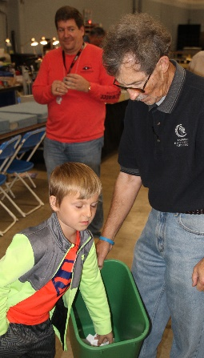

**Young Numismatist Samuel Geiter pulls winning ticket from bucket held by SCNA Secretary Pascal Brock. SCNA Board Member David Durham looks on in the background.**

These three days passed very quickly, and offered a wide-variety of opportunities for the Patrons. It was especially meaningful that ANA President Col. Ellsworth graciously gave his time to discuss his organization, the future of the hobby, initiatives he is creating, and of course coins and currency. This was an invaluable opportunity to learn from one of the best.

Also meaningful was the participation of Mr. Pat McCawley, Director of the South Carolina Department of Archives and History. As he has done for several conventions, Pat brought many obsolete notes from South Carolina’s past to sell to a craving public. The author spent an hour engaging in conversation between himself, Mr. McCawley, and legendary SC numismatist Mr. Hugh Shull, as we looked through the notes Pat had brought. It was an amazing educational opportunity for the author!

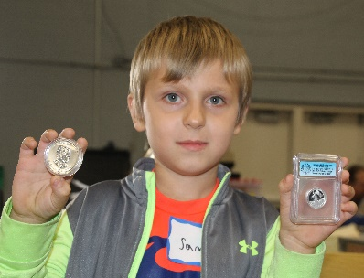

**Samuel Geiter with his "pay" for pulling the winning tickets - A 2010 Silver Maple Leaf and a 2016 silver proof Ft. Moultrie quarter!**

Hopefully you were able to attend the Convention. If you were not able to attend this year, the 2020 Convention (the 48th) will be held the last weekend of next October. Mr. Bill Latour, SCNA Board member and owner of Low Country Coins in Charleston, SC was the Bourse Chair this year and he did an excellent job with the show. He will be the chair for the 2020 show also, so expect excellence to repeat! Finally, Heads Up! The SCNA is rapidly approaching its 50th anniversary in 2022! Planning is already underway and it will be an extra-special show, so be watchful for upcoming announcements over the next two years!

**STEPHEN JAMES CSRA COIN CLUB**

**Regular Meeting October 3, 2019,**

**Aiken County Library**

President J.J. Engel called the regular meeting of the club to order at 6:48 p.m.

Glenn Sanders reported that there were 16 members present, and 3 guests. Robbie Ogden won the members’ door prize, a 2019 Silver Eagle. Glenn announced information concerning several upcoming coin shows in the vicinity.

A motion was made by Willie Simon, seconded by Andy Goslen, and passed to dispense with the reading of the September 2019 meeting minutes. A copy will be on file with the other club records, and a copy will appear in the club newsletter.

Treasurer Chuck Goergen reported the Club’s bank balance is $4266.77.

**Show and Tells** included one by Andy Goslen, who shared the 1/10th oz gold eagle he won at the coin show as well as a 1892-S Barber Half that he bought at our coin show. Arno Safran shared a 1889 Indian Head cent in very high grade. He indicated it was a common date, but an extremely well-struck coin. John Kolmar shared his first example of a cud error - on a 1974-D cent. Chuck Georgen shared a set of a Roman nail along with a widow’s mite, each ~ 2000 years old.

Arno Safran reminded the members of the meeting of the Augusta Coin Club at 7 p.m. on the third Thursday of the month at the Sunrise Grill, West Town Market Square on Washington Road in Martinez, Georgia. The presentation will be by Walt Kubilius on Italian States Coins.

Pat James, Coordinator for the 2019 Coin Show, reported our September show was a great success. Thanks to the 26 members who volunteered to work at the show. The club’s net earnings for the show were $1827.

‘

Glenn Sanders reminded us that the SCNA convention is coming up Oct 25-27 in Greenville. Anyone willing to spend a few hours working at the convention could earn free membership in the SCNA for a year, those working longer would earn an American Silver Eagle.

President JJ Engel reminded us that the club’s Christmas dinner will be at the Columbus Hall on the first Thursday in December. There will be a choice between Steak and Chicken & crab cake, along with a vegetable, potato, and iced tea. The cost will be $10 for members, and $25 for non-members. The doors will open at 6:00 and dinner will be served at about 6:30. Look for an email containing reservation forms.

**The Program**:

Jim Mullaney presented a program on “Brookgreen Gardens – SC Sculpture Trove with Numismatic Ties”. This program provided a brief history of the gardens that were created around 1930 from the land of 4 adjacent rice plantations just down the coast from Myrtle Beach. Anna Hyatt Huntington and her husband originally planned to create the gardens to exhibit sculptures that Anna created, but quickly broadened the purpose to include works by sculptors from across the country. The program displayed works at Brookgreen Gardens from 17 artists who also had a role in creating coins minted by the U.S. The artists ranged from those as well-known as Augustus Saint-Gaudens, Adolph Weinman, and James Fraser and his wife, Laura Fraser to artists less familiar to numismatists such as Constance Ortmayer, Brenda Putnam and Gertrude K. Lathrop who designed commemorative half dollars for 1936 Cincinnati and Cleveland/ Great Lakes and the 1938 New Rochelle, respectively.

Member Ken Olin won $12.00 in the 50-50 drawing.

Following the monthly auction, President Engel adjourned the meeting at 8:35 pm.

Respectfully submitted, Jim Mullaney, Secretary



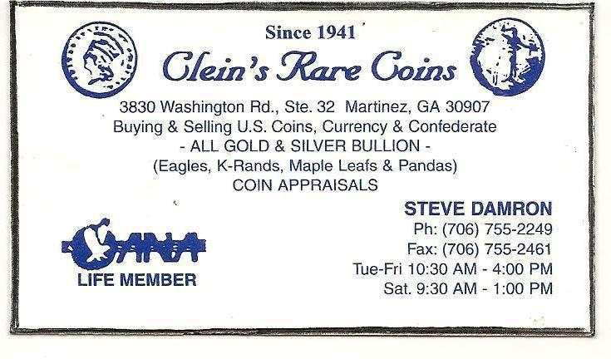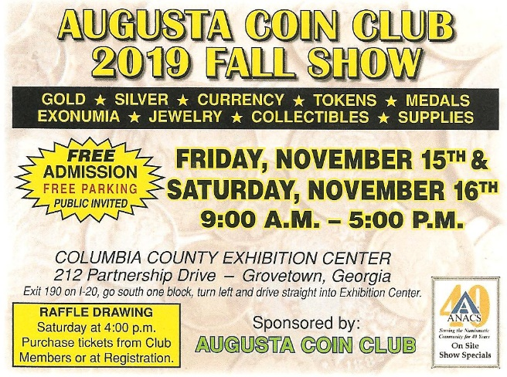

***Upcoming Coin Shows***